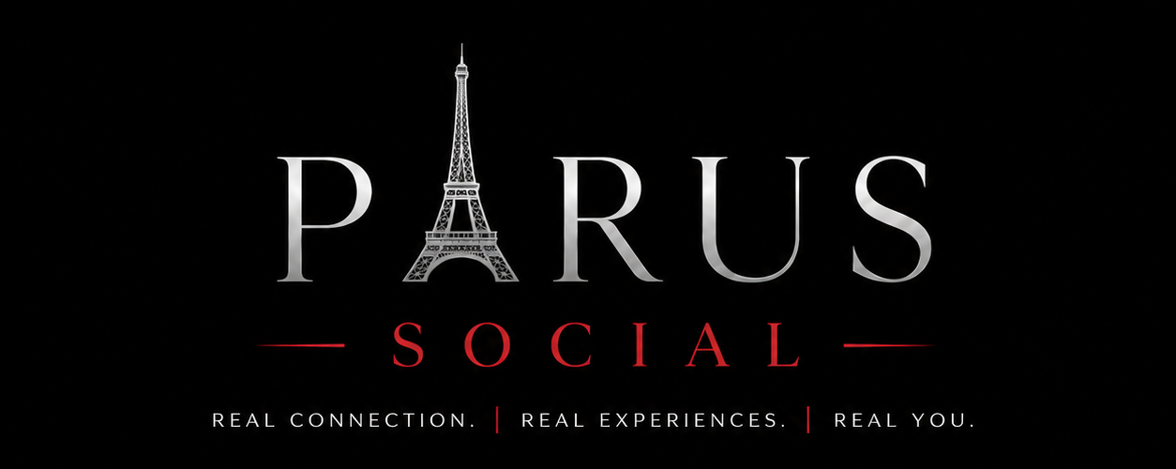
Guided Support Service Agreement

1. Description of Services
PARUS Guided Support offers private one-on-one or couples sessions providing guidance, perspective, and personal development support on topics such as dating, relationships, communication, confidence, personal style, and conflict mediation.

2. Not a Substitute for Therapy
- Wendy Abbott is not a licensed therapist, psychologist, or mental health professional.
- Guided Support sessions do not constitute therapy, counseling, or professional mental health treatment, and are not a substitute for care from a licensed professional. If I am experiencing a mental health crisis, I agree to seek support from a qualified professional.

3. Session Structure
- Standard sessions are typically 45 to 60 minutes in length.
- Same-day support sessions are offered based on availability and may vary in length.

4. Confidentiality
Information shared during a Guided Support session is treated with discretion and will not be shared with third parties without consent, except where required by law or where there is a concern for the safety of the client or others.

5. Payment
Payment for sessions is due at the time of booking unless otherwise agreed. A 3% processing fee applies to credit card payments; no fee applies to e-transfer payments.

6. Acknowledgment
By signing below, I confirm that I have read, understood, and voluntarily agree to the terms of this Guided Support Service Agreement.
Client Name: _______________________________
Signature: _________________________________
Date: ______________________________________

