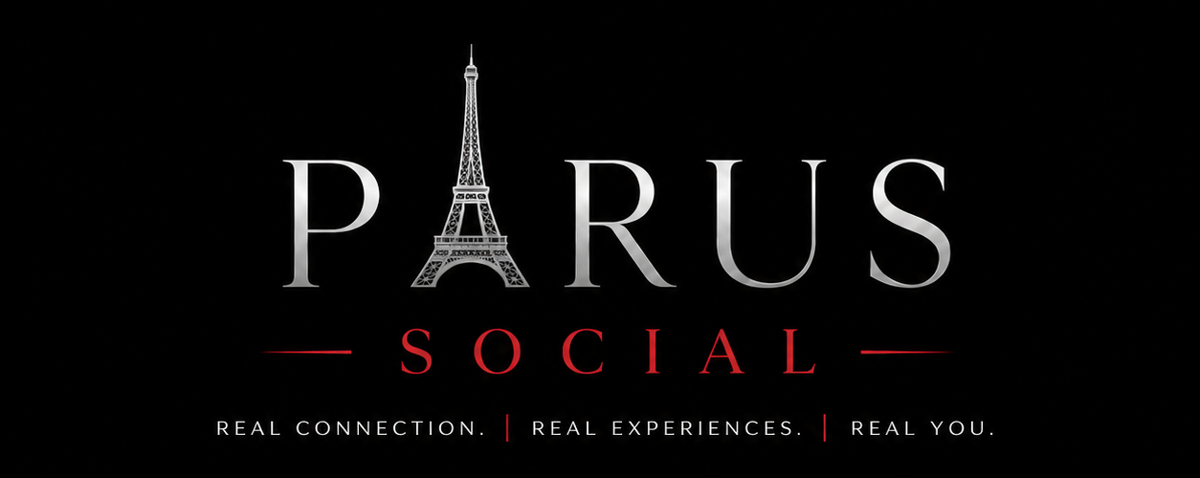
Privacy & Guest Conduct Agreement

1. Our Commitment to Privacy
- PARUS Social will never share a guest's phone number, email address, or other personal contact information with other guests or third parties without the guest's explicit consent.
- All communication prior to and during a retreat or event is coordinated directly through PARUS Social.
- Information collected during the application and vetting process is used solely for guest screening and safety purposes.

2. Guest Conduct Standards
All guests are expected to:
- Treat fellow guests, hosts, and resort or venue staff with respect and courtesy at all times.
- Refrain from any form of harassment, discrimination, or inappropriate conduct toward others.
- Respect the boundaries, comfort, and consent of fellow guests at all times, including around physical contact and personal contact information.
- Follow the guidance of PARUS Social hosts during all events and retreats.

3. Right to Remove a Guest
PARUS Social reserves the right to remove any guest from an event or retreat, without refund, if their conduct violates these standards or compromises the safety or comfort of other guests.

4. Guest Screening
I understand that PARUS Social conducts an application and screening process for all guests, which may include background checks where legally permitted, in order to maintain a safe and respectful environment for everyone.

5. Acknowledgment
By signing below, I confirm that I have read, understood, and agree to abide by the Privacy & Guest Conduct standards outlined in this agreement.
Guest Name: _______________________________
Signature: _________________________________
Date: ______________________________________

